  
***“What do you want to know?”***

Kuipp – Scope of Work: Icons

**Medals** – Medals represent badges, or awards that users are given upon performing/completing certain tasks, such as gaining 50 followers (‘Crew’ medal) or asking/answering more than 100 questions in 1 day (‘Realtime’ medal). Medals should be fun awards users will want to obtain by using the application, playing the game, and competing with their other followers. Medals will be displayed in a format similar to Foursquare’s badges (see below).

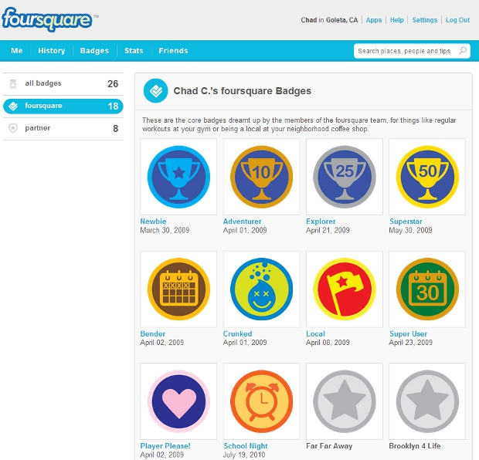 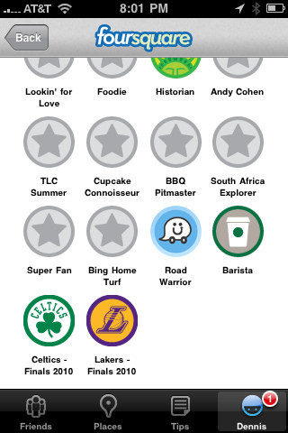

Below is a list of medals, organized by the name of the medal itself and a general description of the medal. While some of the medals are clearer, some may be somewhat vague, so happy to provide additional detail. Although each medal has a name, if you think there is a better name for the medal, we would definitely appreciate any creative insight (as I know I’m not very creative). If you look to the far left column of the list, you will see x’s and ?’s. The ‘x’ represent names that we thought were okay, while the ‘?’ marked names we stuck in but are by no means bound to the name itself (suggestions appreciated). Medals should not be too complicated, but still distinct/unique enough that users will want to show this on their Medals page,

|  |  |  |
| --- | --- | --- |
|  | **Medal Name** | **Description** |
| x | Entourage | 10 Followers |
| x | Crew | 50 Followers |
| x | Crowd | 100 Followers |
| x | Popular | 250 Followers |
| x | Celebrity | 500+ Followers |
|  |  |  |
| ? | Appeal | 20+ responses to a question for the last 5 questions |
| ? | Public Figure | 30+ responses to a question for the last 5 questions |
| ? | Debater | 50+ responses to a question for the last 5 questions |
|  |  |  |
| ? | Responder | Responded to 25 questions in a day or less |
| ? | Rapid Fire | Responded to 25 questions in an hour or less |
| ? | Answer Fiend | Responded to 25 questions in a 15 minutes or less |
|  |  |  |
| ? | Cowboy | Responded to 1 question within 1 minute |
| ? | Volleyer | Responded to 5 questions within 1 minute |
| ? | Slingshot | Responded to 25 questions within 1 minute |
| ? | 911 Dispatcher | Responded to 50+ questions within 1 minute |
|  |  |  |
| x | Nomad | Asked questions in 3 different locations at least 300 miles apart |
| x | Traveler | Asked questions in 2 different continents |
| x | Jetsetter | Asked questions in 3 different continents |
| x | Worldy | Asked questions in 4+ different continents |
|  |  |  |
| x | Focused | Asked / Answered more than 20 questions in 1 day |
| x | Rapid | Asked / Answered more than 50 questions in 1 day |
| x | Realtime | Asked / Answered more than 100 questions in 1 day |
|  |  |  |
| x | Advisor - Arts | 50 questions answered in category topic, over 200 net likes, in 1 month |
| x | Advisor - Dating & Relationships | 50 questions answered in category topic, over 200 net likes, in 1 month |
| x | Advisor - Food, Drink & Lifestyle | 50 questions answered in category topic, over 200 net likes, in 1 month |
| x | Advisor - Life & Society | 50 questions answered in category topic, over 200 net likes, in 1 month |
| x | Advisor - Local News & Current Events | 50 questions answered in category topic, over 200 net likes, in 1 month |
| x | Advisor - Music & Performances | 50 questions answered in category topic, over 200 net likes, in 1 month |
| x | Advisor - Night Life | 50 questions answered in category topic, over 200 net likes, in 1 month |
| x | Advisor - Sports & Recreation | 50 questions answered in category topic, over 200 net likes, in 1 month |
| x | Advisor - Traffic | 50 questions answered in category topic, over 200 net likes, in 1 month |
| x | Advisor - Weather | 50 questions answered in category topic, over 200 net likes, in 1 month |
| x | Exp Advisor | Medal awarded once the 4th Advisor badge is awarded |
| x | Jack-of-Trades | Medal awarded once the 8th Advisor badge is awarded |

**Character Levels –** The purpose of the game when users use the question and answer application is to earn enough points to reach the next character level. The character levels are listed below. Character levels do now have to be contained in a medal, but can be the fully body character or even just the head of the character with some apparel.

* Rookie – this is the 1st level that all users start out with
* Apprentice
* Tutor
* Mentor
* Ninja
* Wizard
* Master
* Guru – the most wise character level users think they can reach.
* Ultimate – this is ‘secret’ final character level that will be very difficult to obtain

To provide a sense of the overall style of our iPhone application, this is the draft layout of a few of the pages. The overall all feel of the application should be a fun gaming environment but still clean enough to be trusted as a valid Q&A mobile application.

